Roll No.:2503a52531
Name:B.Poojitha
Batch:18

Question 4: Context-Managed Prompting (Optimized Number
Classification)
Design a context-managed prompt with clear instructions and
constraints to generate an optimized Python program that classifies a
number as prime, composite, or neither.

Task:
• Ensure proper input validation.
• Optimize the logic for efficiency.
• Compare the output with earlier prompting strategies.

Prompt:
Create an optimized Python program to check whether a number is Prime, Composite, or Neither, with proper input validation.

Code:
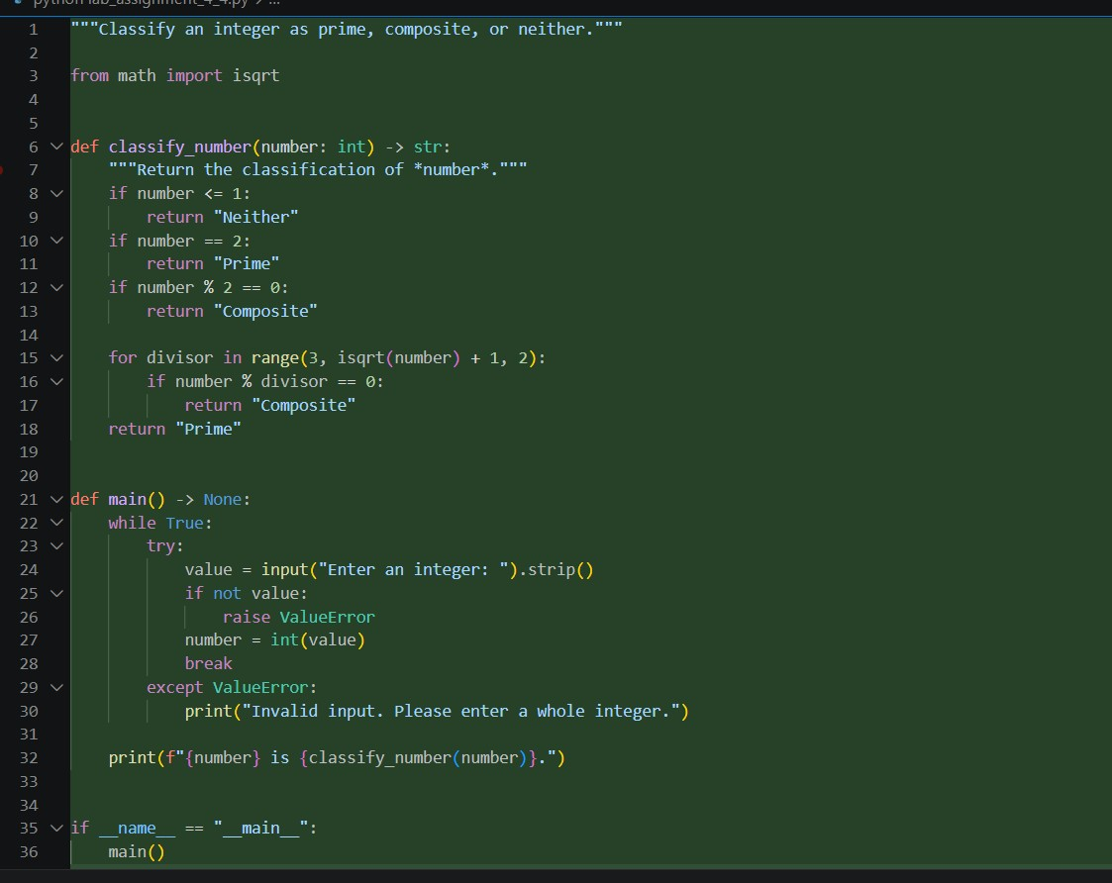
Output:
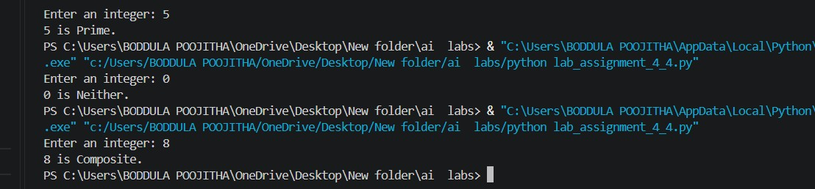
Observation:
1. The context-managed prompt generated an optimized Python program to classify a number as Prime, Composite, or Neither.
2. Clear instructions helped the AI produce a more structured and understandable solution.
3. Proper input validation was included to handle invalid and non-numeric inputs.
4. The program efficiently checks divisibility only up to the square root of the number.
5. Numbers 0 and 1 were correctly classified as Neither Prime nor Composite.

